1.Create ID account
1.1 Enter snowboy website
URL：https://snowboy.kitt.ai/
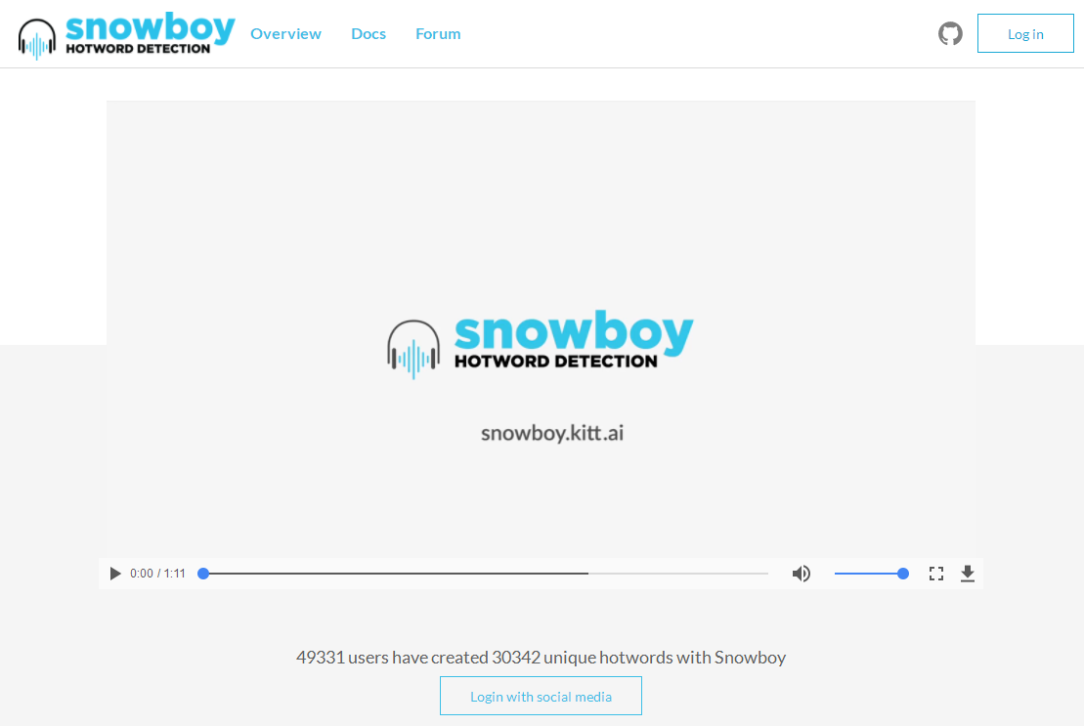
1.2 Click right upper corner Log in button
It will pop up the window for selecting the account type. At this time, you can select the first Login with Github or others option, As shown below.
Tips: I use a Github account in here.
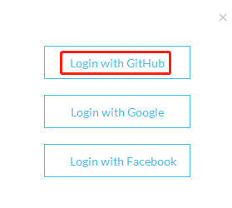
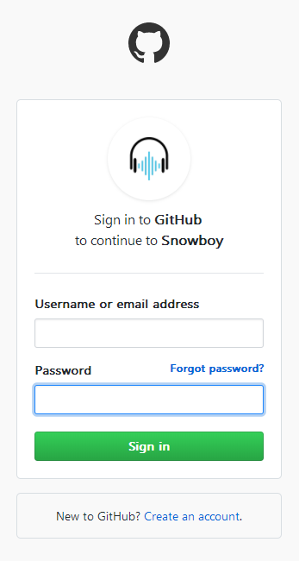
1.3 Input the GitHub account and password. If not, please click “Create an account”, or register on the GitHub official website.
For the registration method, please fill in the information according to the prompts or search related tutorials on the Internet.
After log in successfully, you will see following interface.
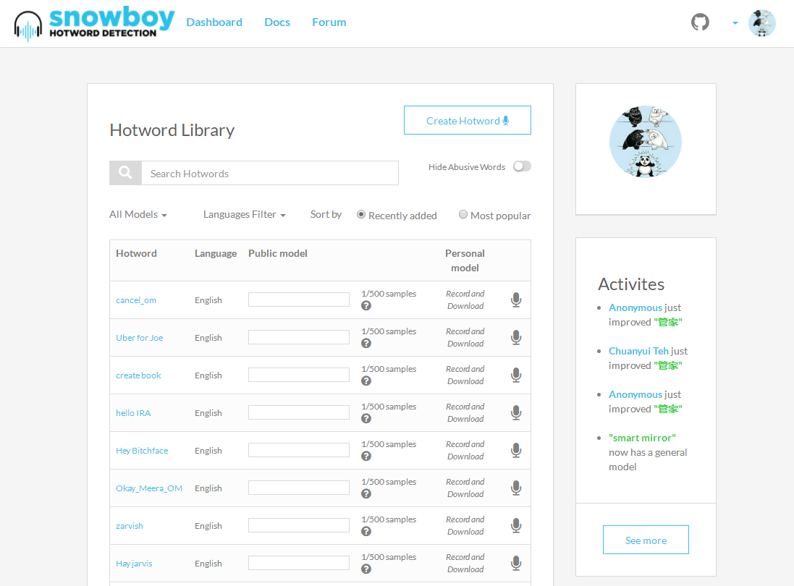

2.Record sound
2.1 2.1 Create a new recording, click “Create Hotword” in the upper right corner.
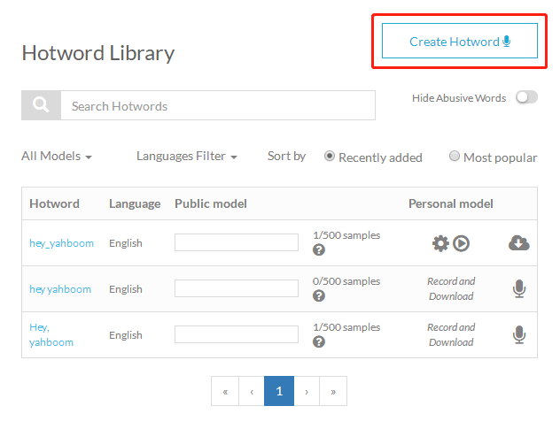

2.2 Fill in the corresponding information and click “Record my voice”.
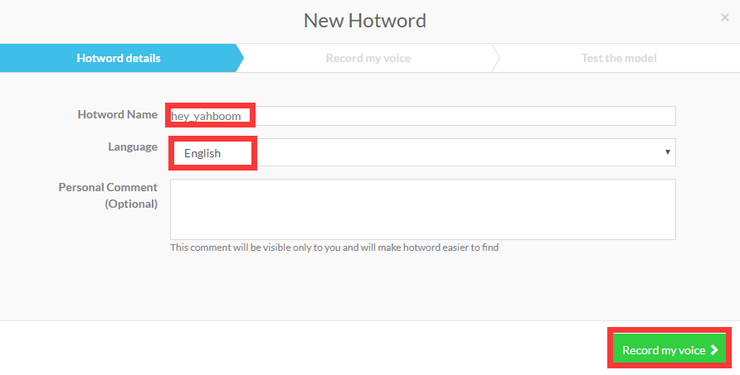

2.3 Click “Record” to record the same sound three times. After recording, then click test the model in the lower right corner.
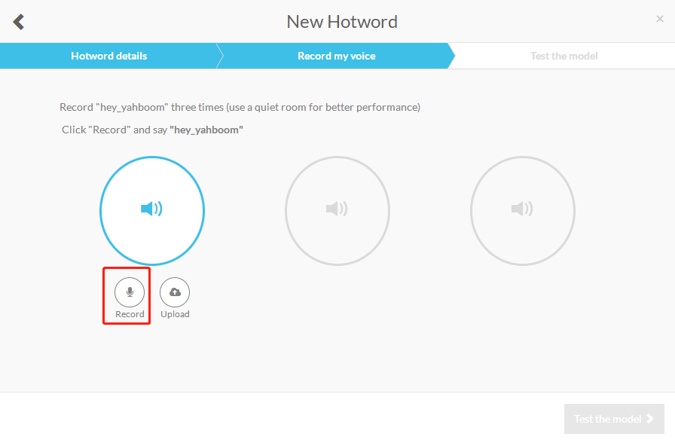
2.4 To verify the recording, select the gender and age and click Run the test to start verification.
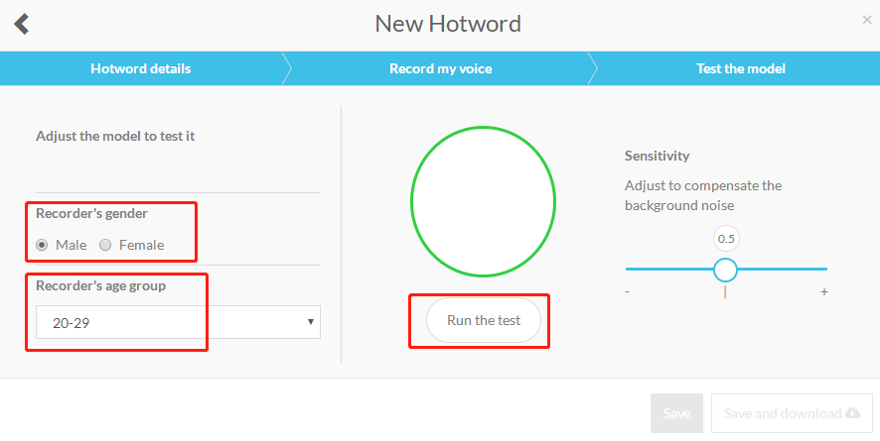

2.5 After the verification voice is completed, it will prompt “Test successful”, and then click “Save and download” in the lower right corner.
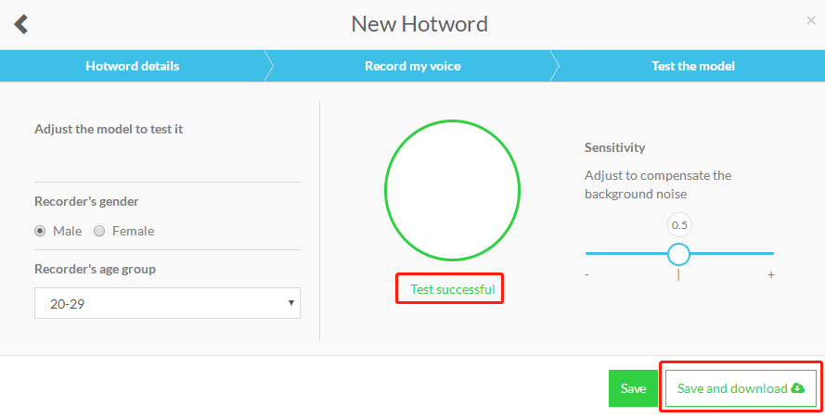

2.6 Download recording file.

2.7 View your own recording, search for the name you defined, and the wake-up voice has been recorded.
